

**Senior Design Project**

**Foodie – A mobile application software**

|  |  |
| --- | --- |
| Md. Mahadi Hasan | 1631551042 |
| Sadia Hossain Meem | 1620268042 |

**Faculty Advisor:**

**Mohammad Ashrafuzzaman Khan Assistant Professor Department of ECE Summer 2021**

LETTER OF TRANSMITTAL

September 2021

To

Dr. Mohammad Rezaul Bari

Associate Professor and Chairman,

Department of Electrical and Computer Engineering,

North South University, Dhaka.

Subject: Submission of Capstone Project on “Foodie – A mobile application”

Dear Sir,

With due respect, we would like to submit our Capstone Project Report on “foodie” as a part of our BSc program. The report deals with an android based application.

We will be highly obliged if you are kind enough to receive this report and provide yourvaluable judgment. It would be our immense pleasure if you find this report useful andinformative to have an apparent perspective on the issue.

Your sincere,

Md. Mahadi Hasan – 1631551042

Sadia Hossain Meem – 1620268042

APPROVAL

The capstone project entitled “Foodie” by Md. Mahadi Hasan (163155104 ) and Sadia Hossain Meem (1620268042), is approved inpartial fulfillment of the requirement of the Degree of Bachelor of Science in Computer Science and Engineering on June, 2021 and has been accepted as satisfactory.

Supervisor:

Mohammad Ashrafuzzaman Khan

Assistant Professor

Department of Electrical and Computer Engineering

North South University

Dhaka, Bangladesh.

Department Chair:

Dr. Mohammad Rezaul Bari

Associate Professor & Chairman

Department of Electrical and Computer Engineering

North South University

Dhaka, Bangladesh.

DECLARATION

This is our truthful declaration that the “Capstone Project Report” we have prepared is not a copy of any “Capstone Project Report” previously made by any other team. We also express our honest confirmation in support of the fact that the said “Capstone Project Report” has neither been used before to fulfill any other course related purpose nor it will be submitted to any other team or authority in future.

.........................................................

Md. Mahadi Hasan

Department of ECE

North South University, Bangladesh

........................................................

Sadia Hossain Meem

Department of ECE

North South University, Bangladesh

**Abstract**

There are few food delivery service in town like Foodpanda. Their activity is to deliver food from local restaurant to customers’ door. Now-a-days “Home Made Food” has become more popular to the food lovers but there is no such platform that can provide this service to the customers. In our daily life, we need healthy foods to survive. People become more busy than ever. People living in urban life are more concious about their health. Sometimes people can not rely on local restaurants food. Because some are being caught by the authorities for food hygiene issues.

TABLE OF CONTENTS

Chapter 1: Introduction............................................ 1

Chapter 2: Literature review.................................... 3

Chapter 3: Methodoly.............................................. 6

3.1: Flow Chart ........................................ 6

3.2: User Interface Design ....................... 8

Chapter 4: Result and discussion............................10

Chapter 5: Conclusion.............................................12

Apendix...................................................................14

CHAPTER 1: INTRODUCTION

**1.INTRODUCTION**

Our goal is to make a suitable platform/android application where anyone who can cook or love to cook can create his/her own profile to sell home made foods to the customer.This was a bit difficult because of the upgration of the documentation. Setting up the environment was one of the major issues.

CHAPTER 2 : LITERATURE REVIEW

**2.LITERATURE REVIEW**

Foodpanda,HungryNaki.com dedicated food delivery company, currently delivering food to the customers’ doorstep from local restaurants. They use mobile app to recieve orders from customers. Their are few other delivery companies they also deliver foods as per conditions like pathao food, shohoj food etc. All of these delivers local restaurants foods. We found none works with ‘**Home Made Food**.’

CHAPTER 3 : METHODOLOGY

**3.METHODOLGY**

Hardware : PC , Softwares : Figma – App layout design, Android Studio – For application code implementation, Database – Firebase Database were used. Here are some complete flow chart diagram of the project.

**3.1 FLOW CHART**

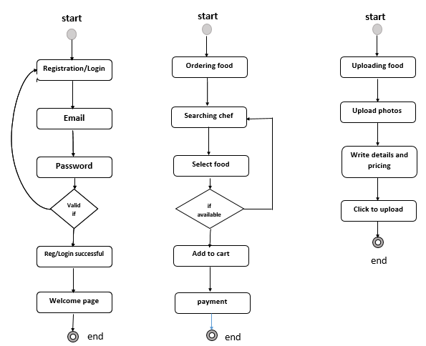

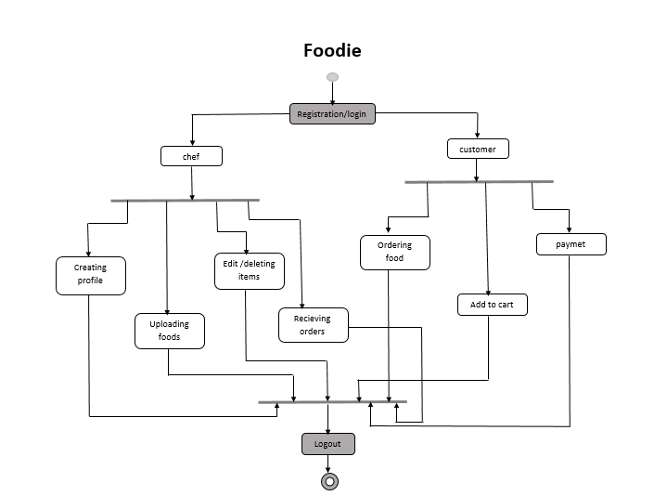

Some basic faunctionalities of our project are mentioned below:

For Chef :

* Registration and login
* Creating food list
* Update/deletion items
* Order billing
* Hand over to delivery

For Customers :

* Registration and login
* Ordering Food
* Add to cart
* Payment

**3.2 USER INTERFACE DESIGN**

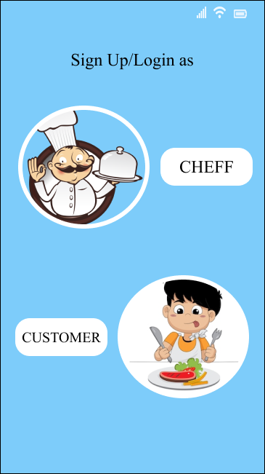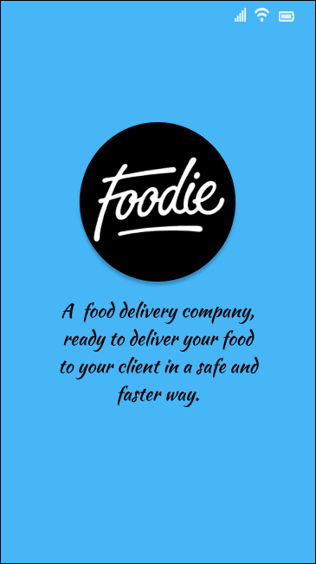

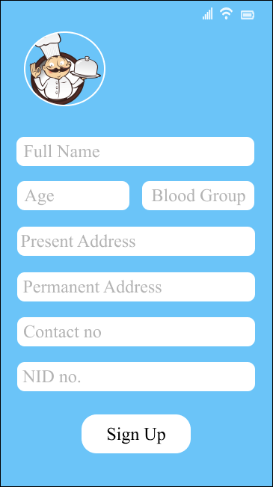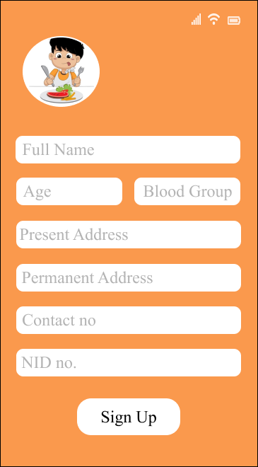

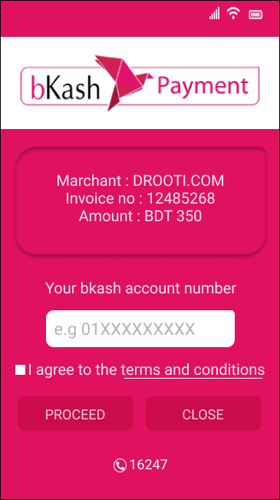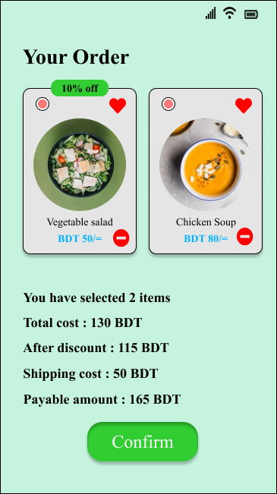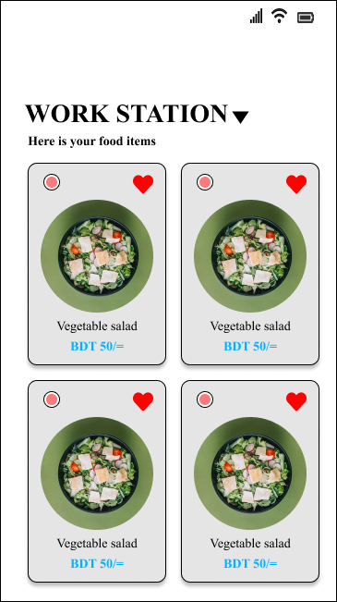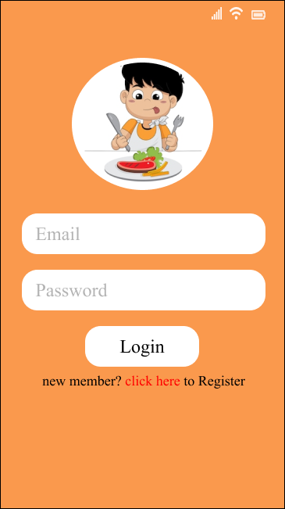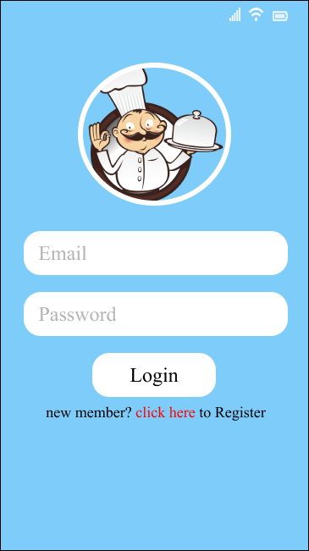

CHAPTER 4 : RESULT & DISCUSSION

**4.RESULT & DISCUSSION :**

We first researched the sustainabilty of this app. Find out if there has any other app similar like this in the market. Then Designed the features and draw diagrams,front end design.Then we start the implementation of the backend code. Here is a screenshot of our backend of the app.

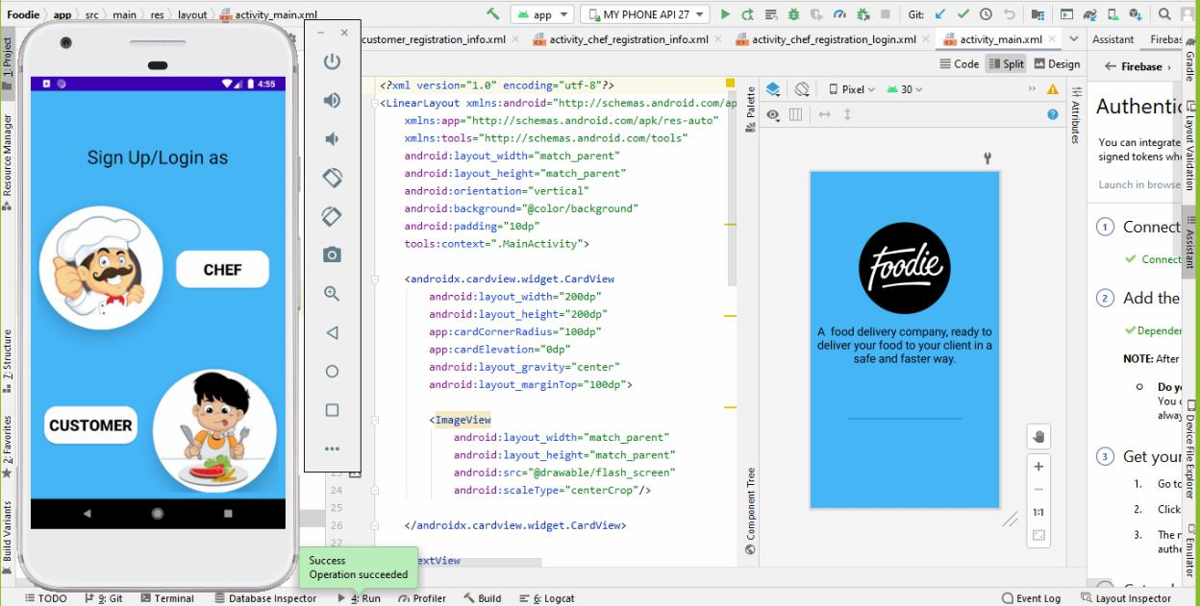

This app may be a good platform for both the chef and the customers who like homemade foods. We successfully buil these apps within a short period of time. But we could not complete the payment gateway part because of gateway link which bkash only provide for the business app. This app will be under testing for further development or adding features in the future.

CHAPTER 5 : CONCLUSION

**5.CONCLUSION :**

People are more health concious than before. They like home made food most. Our app “Foodie” will create a platform for those health concious people who rely more on homemade food than outside restaurant foods. Chef must ensure the quality of the food.

APPENDIX

**References :**

1. [https://developer.android.com/about/versions/11?gclid=Cj](https://developer.android.com/about/versions/11?gclid=CjwKCAjwvuGJBhB1EiwACU1AiSf_A8ybPUgXBVwM--_8f6vAmZJ51RazCSXIQrfVIwBp_KfZi1vDlBoCWjAQAvD_BwE&gclsrc=aw.ds) [wKCAjwvuGJBhB1EiwACU1AiSf_A8ybPUgXBVwM--](https://developer.android.com/about/versions/11?gclid=CjwKCAjwvuGJBhB1EiwACU1AiSf_A8ybPUgXBVwM--_8f6vAmZJ51RazCSXIQrfVIwBp_KfZi1vDlBoCWjAQAvD_BwE&gclsrc=aw.ds) [_8f6vAmZJ51RazCSXIQrfVIwBp_KfZi1vDlBoCWjAQA](https://developer.android.com/about/versions/11?gclid=CjwKCAjwvuGJBhB1EiwACU1AiSf_A8ybPUgXBVwM--_8f6vAmZJ51RazCSXIQrfVIwBp_KfZi1vDlBoCWjAQAvD_BwE&gclsrc=aw.ds) [vD_BwE&gclsrc=aw.ds](https://developer.android.com/about/versions/11?gclid=CjwKCAjwvuGJBhB1EiwACU1AiSf_A8ybPUgXBVwM--_8f6vAmZJ51RazCSXIQrfVIwBp_KfZi1vDlBoCWjAQAvD_BwE&gclsrc=aw.ds)
2. [www.youtube.com](http://www.youtube.com)
3. [https://www.google.com](https://www.google.com/)
4. <https://stackoverflow.com/>
5. <https://developer.android.com/studio>
6. <https://firebase.google.com/?gclid=Cj0KCQiAoNWOBhCwARIsAAiHnEiGRU4r6zorfmK6ZsdwQWdeKkYOYglHxJvF_-zQZYnWrzxh9ygY1r4aAsJlEALw_wcB&gclsrc=aw.ds>